Computer Network: Lab 4

Name:Rithvik Rajesh Matta
SRN: PES2UG23CS485
Section: H

Topic:
Wired Simulation using NS2

Explanation:
Creation of 3 nodes sending packets to each other with the help of NS2, NSG2.1 and NAM.

NSG2.1
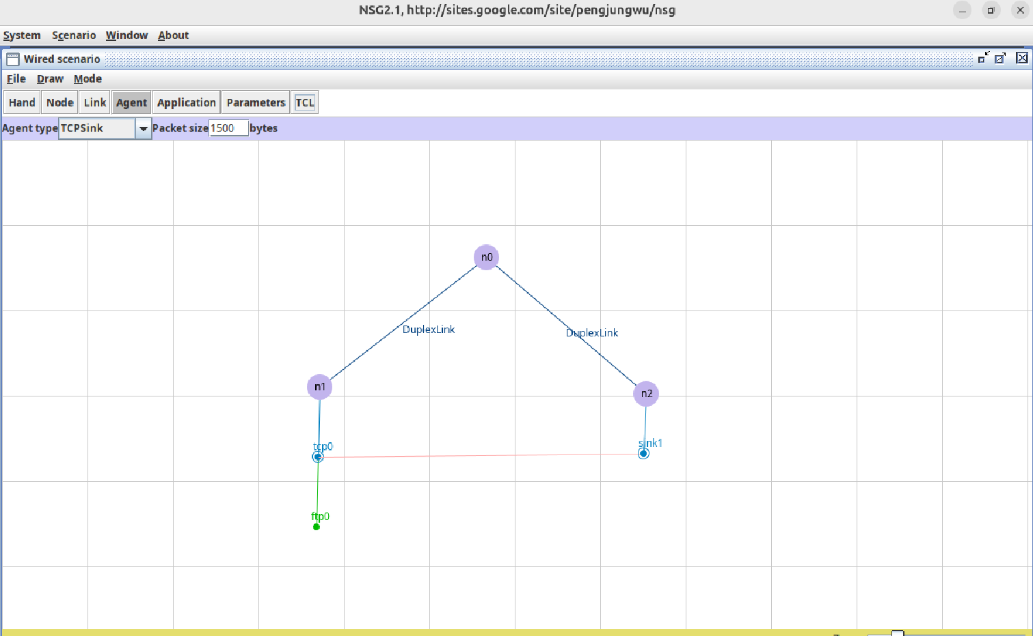
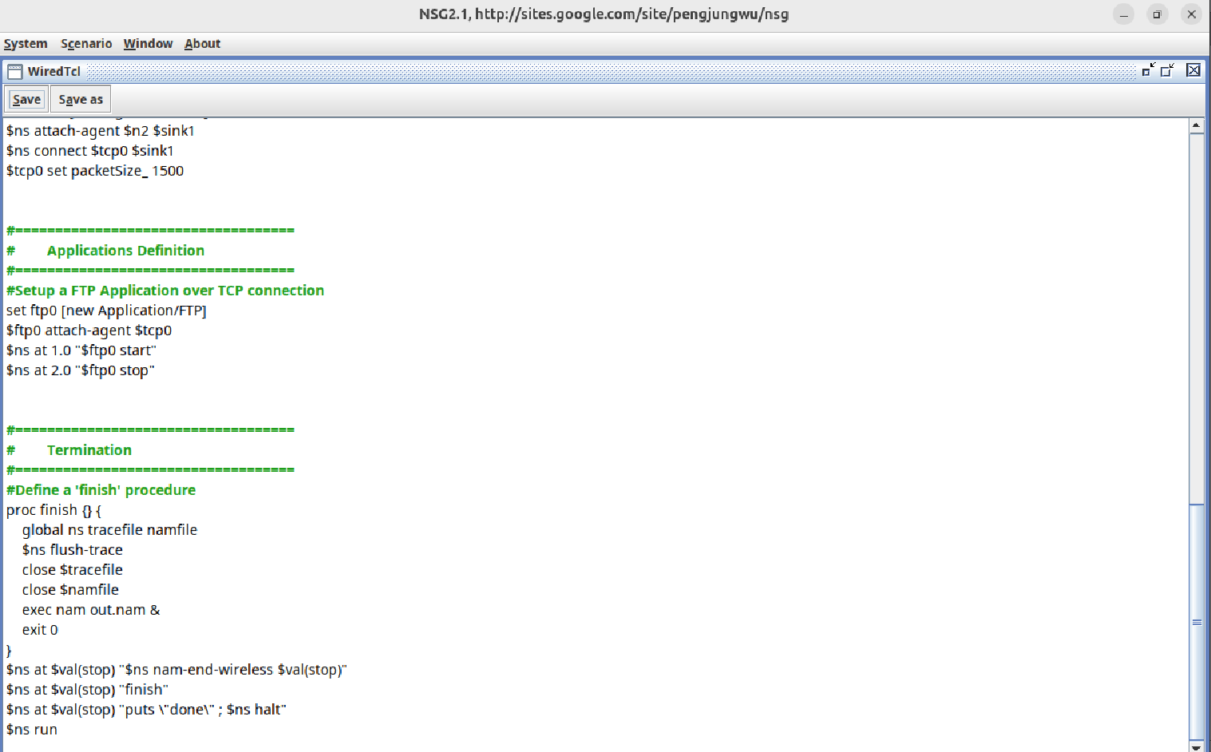

NAM
